**[GitHub Links](https://github.com/aishwaryanr/awesome-generative-ai-guide?tab=readme-ov-file" \l "book-list-of-free-genai-courses)**

**Generative AI tech stack**, frameworks, and the surrounding ecosystem

**1. Foundational Layers**

**Hardware Infrastructure**

* **GPUs and TPUs**: High-performance hardware like NVIDIA GPUs and Google TPUs, optimized for training and inference of large generative models.
* **Storage Systems**: Distributed storage solutions to manage the vast datasets used for training (e.g., Amazon S3, Google Cloud Storage).
* **Networking**: High-bandwidth and low-latency networks for distributed training.

**Cloud and Compute Providers**

* **Cloud Platforms**: AWS, Google Cloud Platform (GCP), Microsoft Azure provide compute instances, managed AI services, and storage.
* **Specialized Platforms**: Hugging Face and Lambda Labs offer dedicated services for training and deploying generative models.

**2. AI Development Frameworks**

**Programming Languages**

* **Python**: The primary language for AI/ML due to its extensive library support.
* **Other Languages**: R, Julia, and JavaScript (for browser-based AI).

**Deep Learning Frameworks**

* **TensorFlow**: Google's open-source framework for machine learning and deep learning.
* **PyTorch**: A flexible and widely used framework developed by Meta, particularly popular in academic and research settings.
* **JAX**: Google's library for high-performance numerical computing and machine learning, with a focus on automatic differentiation.

**Specialized Libraries**

* **Transformers (Hugging Face)**: Pre-built models and tools for working with transformer architectures like GPT, BERT, etc.
* **Diffusers (Hugging Face)**: For creating image and video generative models like Stable Diffusion.
* **Sentence Transformers**: Efficient tools for embeddings and semantic similarity.

**3. Generative AI Architectures**

**Core Model Types**

* **Transformer-Based Models**:
  + Text: GPT (OpenAI), BERT (Google), LLaMA (Meta).
  + Multimodal: CLIP, DALL·E, Flamingo.
* **Diffusion Models**: DALL·E 2, Stable Diffusion, MidJourney.
* **GANs (Generative Adversarial Networks)**: Pioneers in image generation (e.g., StyleGAN).
* **Autoencoders**: Variational Autoencoders (VAEs) for encoding and generating high-dimensional data.

**Open-Source Models**

* **Stable Diffusion**: A diffusion model for image generation.
* **LLaMA**: Meta’s open-source LLM.
* **Bloom**: Multilingual open-source LLM by BigScience.

**4. Tools and Ecosystem for Development**

**Model Training and Fine-Tuning**

* **Hugging Face**: Tools for pre-trained model fine-tuning and deployment.
* **Weights & Biases**: Experiment tracking and hyperparameter optimization.
* **Ray**: Scalable distributed training and serving platform.

**Data Management**

* **Datasets**: Hugging Face Datasets, Kaggle, Google Dataset Search.
* **Data Labeling**: Labelbox, Scale AI.
* **ETL Tools**: Apache Airflow, dbt for data preparation pipelines.

**Inference and Deployment**

* **Inference Engines**: ONNX Runtime, TensorRT.
* **Model Serving**: NVIDIA Triton, TorchServe, FastAPI.
* **Deployment Platforms**: Docker, Kubernetes, AWS SageMaker, Google Vertex AI.

**5. User Interfaces and Interaction**

**Generative Applications**

* **Text Generation**: ChatGPT, Jasper AI, Writesonic.
* **Image Generation**: MidJourney, Stable Diffusion, DALL·E.
* **Audio and Video**: Descript (text-to-video/audio editing), Runway AI.

**Interactive Tools**

* **Notebooks**: Jupyter, Google Colab.
* **APIs**: OpenAI API, Cohere, AssemblyAI.

**6. Ecosystem and Integrations**

**Middleware and APIs**

* **OpenAI API**: Access to GPT, DALL·E, Codex, and other models.
* **Hugging Face Spaces**: Hosting and sharing AI demos and applications.
* **LangChain**: Orchestrating LLMs with context and memory for workflows.

**Collaboration Tools**

* **GitHub**: Version control for AI projects.
* **Databricks**: Collaborative data and AI workflows.
* **Slack/Discord**: For developer and community collaboration.

**7. Monitoring and Governance**

**Model Performance Monitoring**

* **MLflow**: Experimentation and monitoring.
* **WhyLabs**: Drift detection and quality monitoring.

**Ethical AI**

* **Fairness and Bias**: IBM AI Fairness 360, Google’s What-If Tool.
* **Explainability**: SHAP, LIME for model interpretability.

**Emerging Trends**

* **Multimodal AI**: Unified models that work across text, images, and videos.
* **Foundation Models**: Large models like GPT-4 and LLaMA, fine-tuned for specific tasks.
* **Edge AI**: Deploying generative models on edge devices for real-time applications.

**Real-Time Example: Automated Customer Support with Generative AI**

**Scenario**:  
A leading **e-commerce platform** uses generative AI to provide instant customer support via a chatbot. The bot resolves inquiries about order status, product recommendations, and return policies in real time.

**Tech Stack in Action**

**1. Hardware Infrastructure**

* **Cloud Provider**: Google Cloud Platform (GCP) for hosting the AI model.
* **Compute**: NVIDIA GPUs (A100) on GCP for model inference to handle large-scale requests in real time.

**2. AI Model**

* **Core Model**: OpenAI’s GPT-4 for natural language understanding and generation.
* **Fine-Tuned Variant**: Fine-tuned on company-specific customer service scripts and FAQs using Hugging Face Transformers.

**3. User Interaction**

* **Frontend**:
  + A **React.js** web application integrated with the chatbot interface.
  + A mobile app version built using **Flutter**.
* **Backend**:
  + A **FastAPI** server orchestrates communication between the AI model and the user interface.
  + WebSocket enables real-time messaging between the user and the bot.

**4. Deployment**

* **API Integration**:
  + The chatbot communicates with GPT-4 via OpenAI’s API.
  + Stable Diffusion API generates personalized product banners or visuals if needed during the conversation.
* **Hosting**:
  + Deployed using **Kubernetes** for scalability, with auto-scaling enabled to handle peak traffic.
  + Serverless functions on AWS Lambda for lightweight operations like checking order status.

**5. Real-Time Processing**

* **Query Handling**:
  + The bot processes natural language queries in real-time and matches them with the most relevant information from its fine-tuned database.
  + Example:
    - User: *"Where's my order?"*
    - AI Response: *"Your order, #12345, is out for delivery and will arrive tomorrow."*
* **Dynamic Personalization**:
  + If the user asks for product recommendations, the bot uses collaborative filtering algorithms in real-time to suggest products.
    - Example:
      * User: *"What do you recommend for winter wear?"*
      * AI Response: *"We recommend this fleece jacket and these thermal gloves, currently on discount!"*

**6. Monitoring**

* **Performance Metrics**:
  + Monitor query response times and resolution rates using **Datadog** or **New Relic**.
  + Use **WhyLabs** for monitoring data drift in customer preferences.
* **Customer Feedback**:
  + AI collects feedback at the end of each session to improve responses.

**7. Ecosystem Integration**

* **CRM Tools**: Integrates with Salesforce to fetch order details and update customer interaction logs.
* **Knowledge Base**: Connected to a CMS (e.g., WordPress or Confluence) for dynamic FAQ updates.

**Real-Time Impact**

1. **Faster Resolutions**: 80% of customer queries are resolved instantly without human intervention.
2. **Enhanced Experience**: Customers receive tailored responses and product visuals, improving satisfaction.
3. **Cost Efficiency**: Reduced reliance on human agents during off-hours, saving operational costs.

**Live Example in the Market**

* **Amazon Alexa's customer support**: Handles queries about orders, returns, and product recommendations using real-time AI.
* **Instacart AI Chatbot**: Assists customers in resolving delivery issues or recommending grocery products instantly.

High-level architecture of Generative AI (Gen AI)

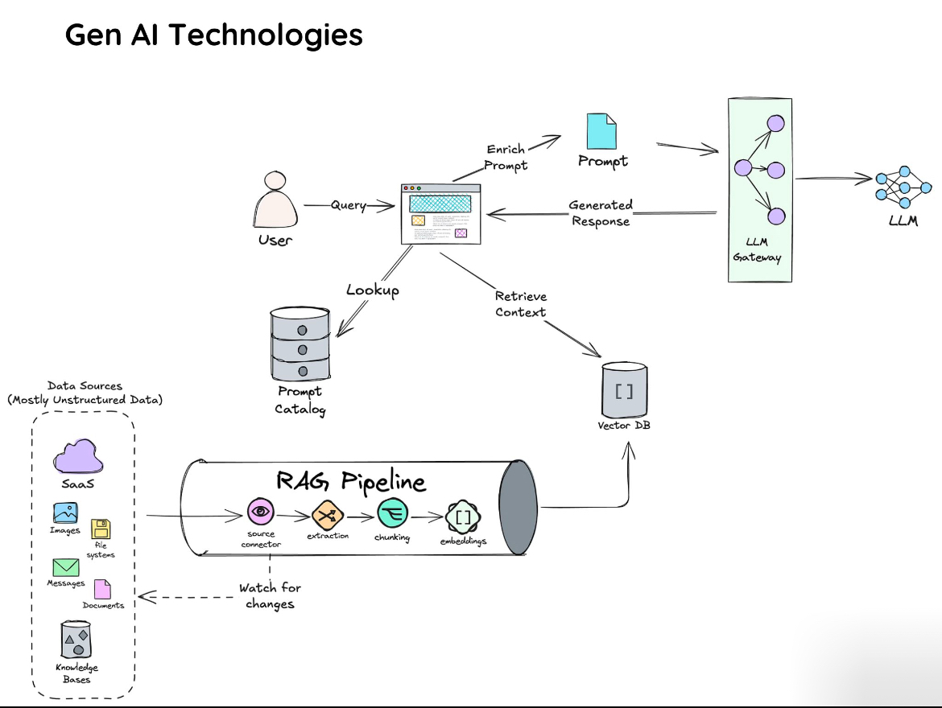

a high-level architecture of Generative AI (Gen AI) technologies, integrating components like data sources, retrieval-augmented generation (RAG) pipelines, vector databases, and large language models (LLMs). Here's an explanation of the workflow:

1. **User Query**:
   * A user submits a query through an interface.
2. **Prompt Enrichment**:
   * The system enriches the user query into a well-structured prompt using data from a **Prompt Catalog**.
3. **LLM Gateway**:
   * The enriched prompt is sent to the **LLM Gateway**, which interacts with the Large Language Model (LLM) to generate a response.
4. **Generated Response**:
   * The LLM generates a contextual response and sends it back to the user.
5. **RAG Pipeline**:
   * For more context-aware responses, a **RAG (Retrieval-Augmented Generation) Pipeline** processes data:
     + **Source Connector**: Extracts data from various sources (e.g., SaaS, images, files, documents).
     + **Extraction**: Pulls relevant information from unstructured or semi-structured data.
     + **Chunking**: Breaks the extracted data into manageable pieces.
     + **Embeddings**: Converts the data into numerical representations suitable for storage in a **Vector Database**.
6. **Vector Database**:
   * Stores embeddings for quick retrieval of contextually relevant data. Queries can retrieve additional context from here to enrich responses.
7. **Feedback Loop**:
   * The system continuously monitors for changes in data sources and updates the RAG pipeline accordingly.

**1. User Query**

* **Purpose**: This is the starting point where the user initiates a request. The query could be a question, a task, or any input requiring processing by the system.
* **Example**: "Summarize this document" or "What is the weather in London today?"

**2. Prompt Catalog**

* **Role**: A repository of predefined prompts or templates designed to optimize the interaction with the LLM. It helps structure and contextualize user inputs.
* **Purpose**: Ensures that the prompt sent to the LLM is clear and aligns with the task.
* **Example**: If a user query is vague, such as "Tell me about AI," the catalog might enrich it to "Provide a 300-word summary of the history of AI."

**3. RAG (Retrieval-Augmented Generation) Pipeline**

The RAG pipeline is crucial for generating responses grounded in factual, up-to-date information by integrating retrieval mechanisms with generative AI.

* **Components**:
  + **Source Connector**:
    - Connects to diverse data sources (e.g., SaaS tools, images, documents, knowledge bases).
    - Ensures real-time or near-real-time access to dynamic information.
    - **Example**: Integrating with a CRM to fetch customer details.
  + **Extraction**:
    - Extracts raw data from connected sources.
    - Handles various formats (e.g., text, tables, multimedia).
    - **Example**: Extracting key-value pairs from invoices.
  + **Chunking**:
    - Splits extracted data into smaller, meaningful chunks to enhance searchability and relevance.
    - **Example**: Breaking a document into paragraphs or sentences.
  + **Embeddings**:
    - Converts chunks into vector representations (numerical formats).
    - These embeddings encode the semantic meaning of the data, enabling effective matching with user queries.
    - **Example**: The phrase "machine learning" might be represented as a dense 512-dimensional vector.
* **Purpose**: Enhances the generative capabilities of the LLM by grounding it in specific, retrievable context.

**4. Vector Database**

* **Role**: Stores the embeddings generated by the RAG pipeline.
* **Purpose**: Allows for fast similarity searches to find the most relevant information for a given query.
* **Example**: When a query is submitted, the system retrieves related vectors, such as similar document chunks, and provides them as context for the LLM.

**5. LLM Gateway**

* **Role**: Serves as the middleware between the enriched prompt and the LLM.
* **Purpose**: Optimizes communication with the LLM, potentially handling load balancing, API requests, or model selection.
* **Example**: Decides whether to use GPT-4, PaLM, or another LLM based on the prompt's complexity.

**6. Generated Response**

* **Role**: The final output produced by the LLM, informed by both the enriched prompt and additional context retrieved via the RAG pipeline.
* **Example**: A complete, fact-based response to "What are the top benefits of AI in healthcare?"

**7. Monitoring and Updates**

* The system continually watches for updates in the connected data sources.
* **Purpose**: Ensures the vector database and RAG pipeline stay updated to provide accurate, real-time responses.
* **Example**: If a SaaS platform updates its data, the system automatically incorporates these changes into the database.